# CS 255 System Design Document Template

This template lays out all the different sections that you need to complete for Project Two. Each section has guidance to prompt your thinking. You will need to continually reference the interview transcript as you work to make sure that you are addressing your client’s needs. There is no required length for the final document. Instead the goal is to complete each section based on what your client’s needs are. Remove this note when you are finished, and replace all bracketed text with the relevant information.

## UML Diagrams

### UML Use Case Diagram

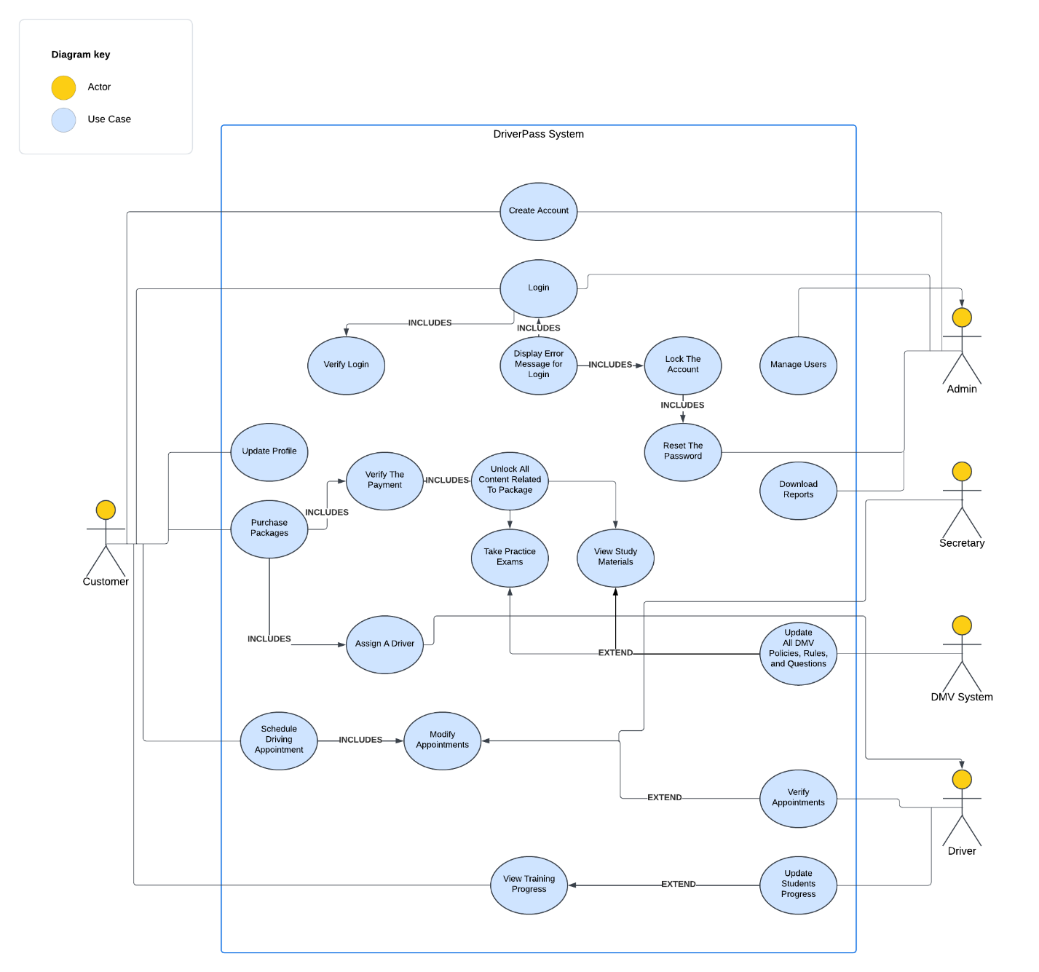

### UML Activity Diagrams

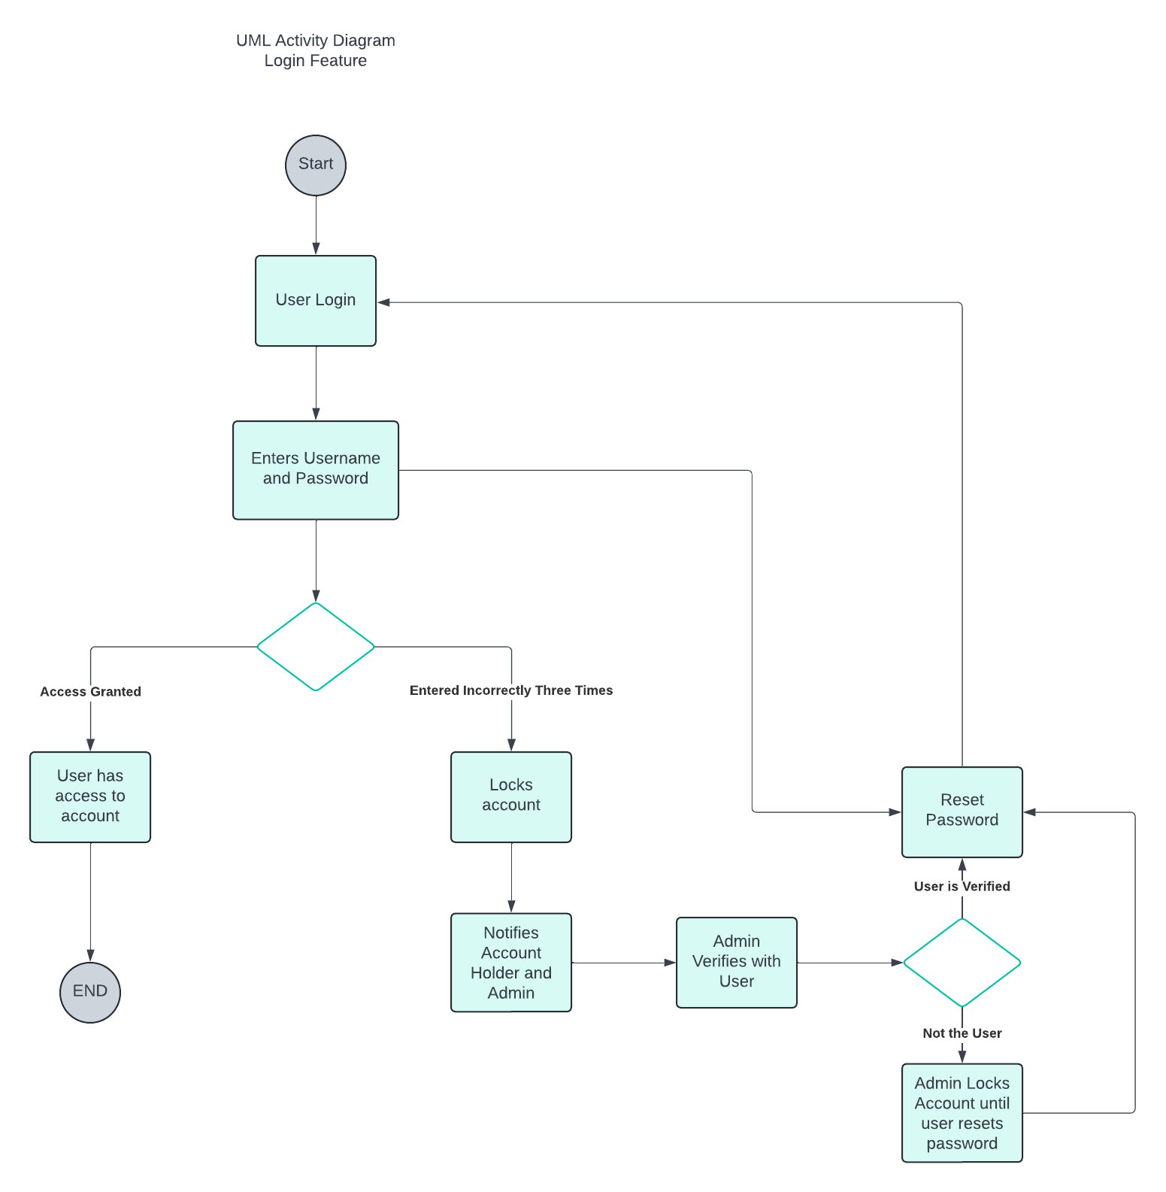

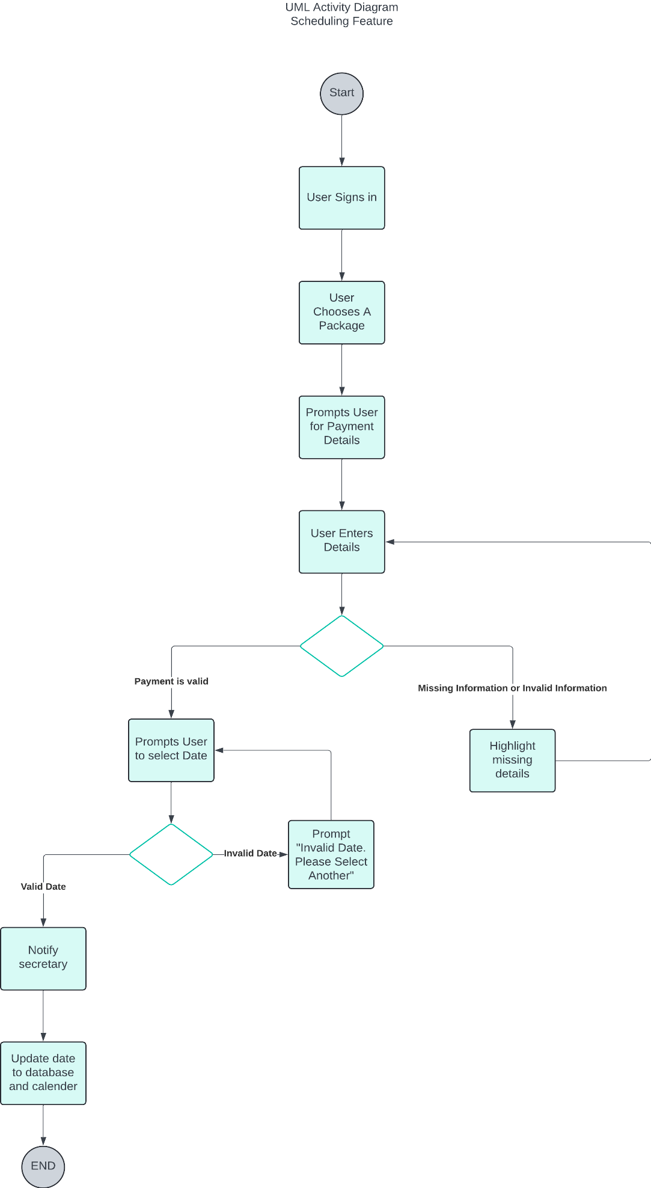

### UML Sequence Diagram

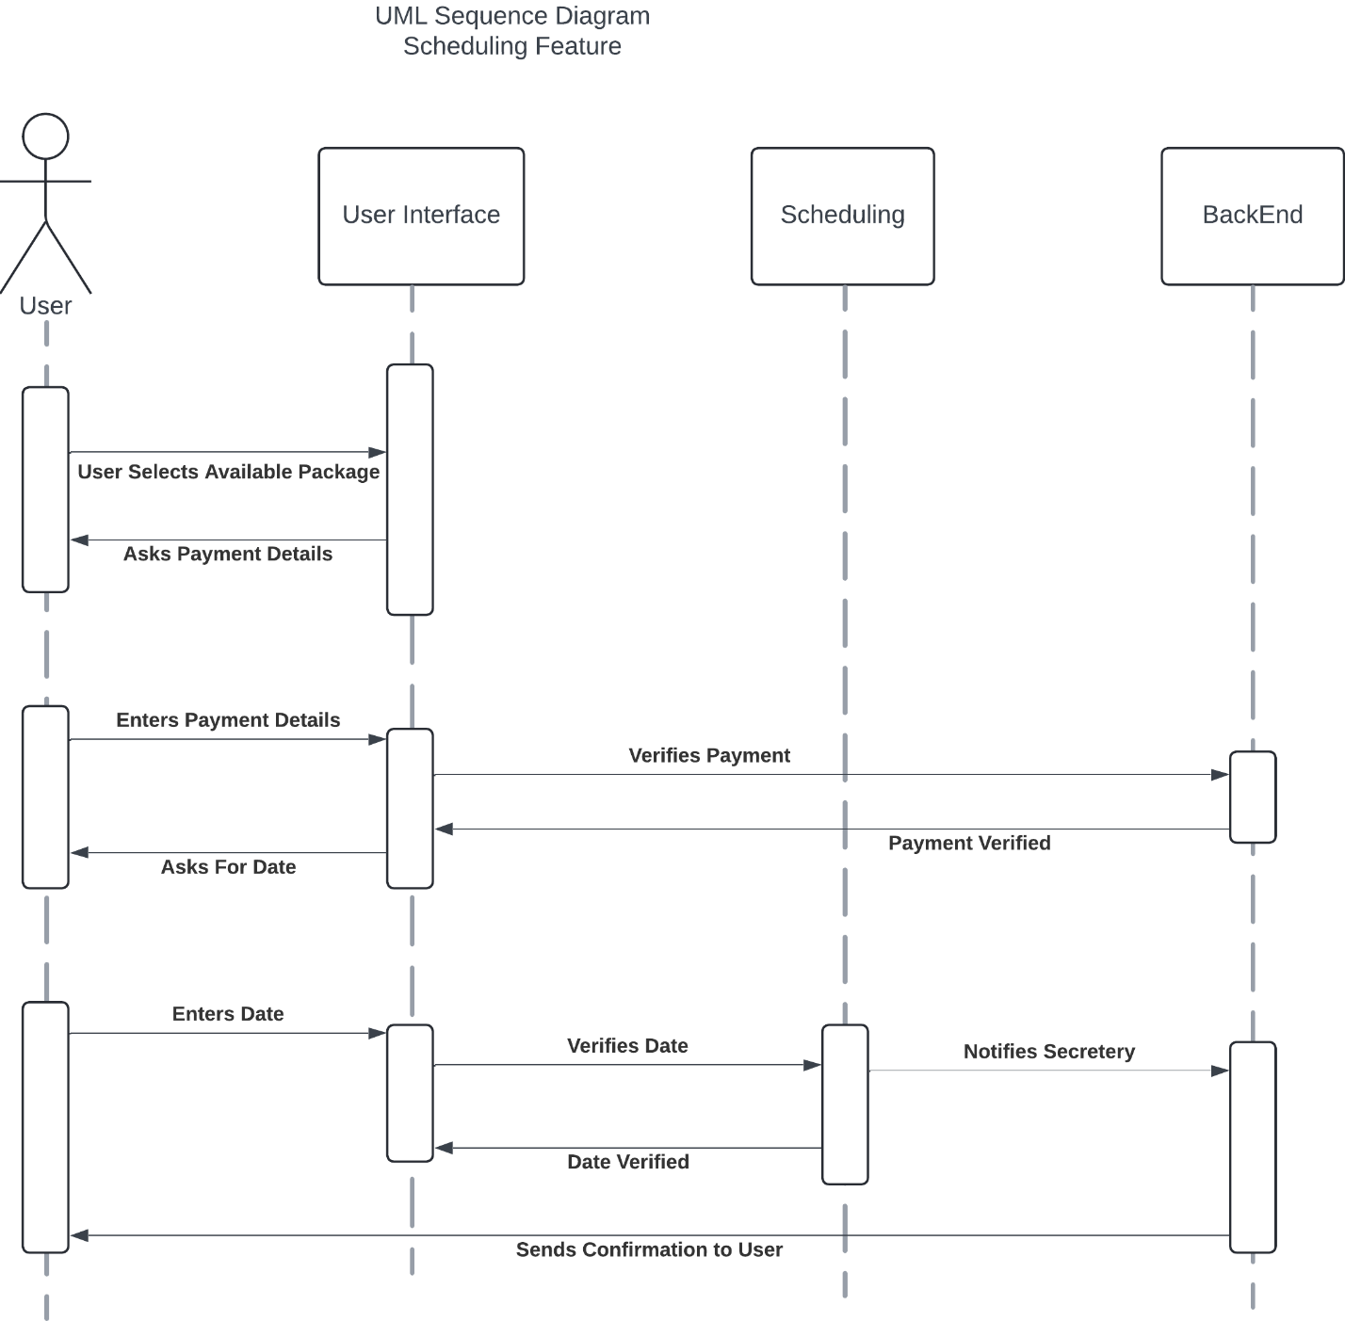

### UML Class Diagram

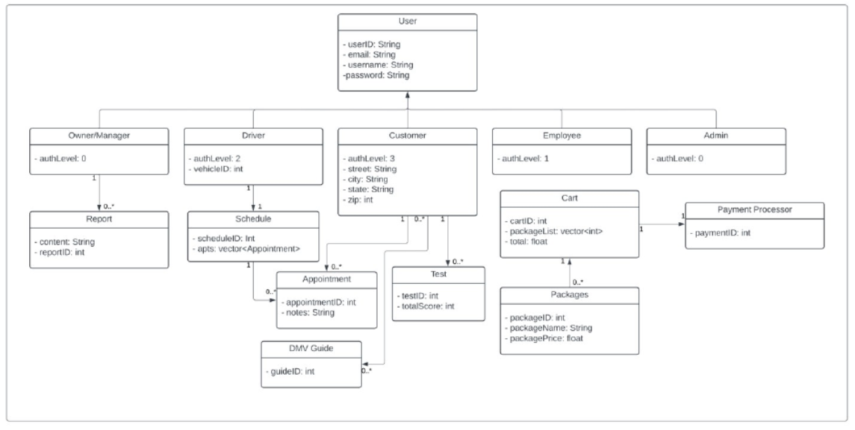

## Technical Requirements

Based on the requirements of the system, we will focus on two aspects, the hardware and software requirements. For hardware, we will need to have a dedicated server, an adequate amount of storage for all database data and information stored, and possibly a firewall implementation to ensure security on website ports. Additionally, for software requirements, we will need to deploy databases, SQL Server is recommended for relational database implementation. We will also need to integrate a cloud provider and implement backup measures for all stored data to ensure that a safeguard is in place.